Heartfelt Guest Care Registration
Step One:
The link will bring you to this page. Please click Next to register
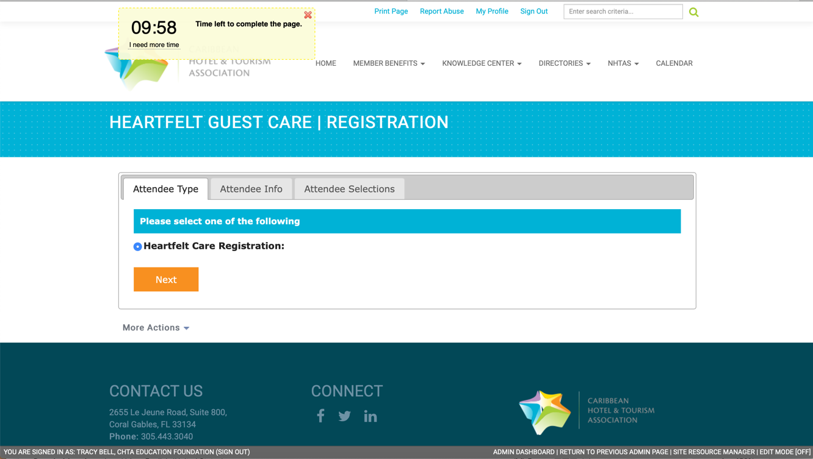
Step Two:
Enter the participant’s name, hotel name and email address. This email address can either be the participant’s or the hotel head of department who is completing this form on behalf of several participants
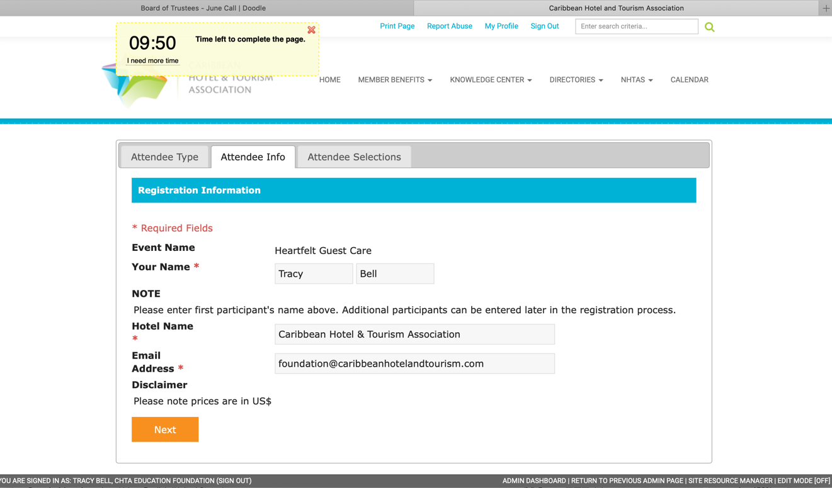
Step Three:
Please select the date for the training the participant will attend. Only one may be selected.
If registering only one participant, please click Save & Finalize Registration and continue to Step Four
If registering several delegates, please click Save & Add Another Attendee.
- This will return you to Step One.
- You may add as many participants as you would like using this process.
- The form allows 10-minutes to complete the entire registration, however at any time you may restart the timer by clicking I need more time directly below the timer at the top left of the form.
Once you have registered all the participants, please click Save & Finalize Registration and continue to Step Four
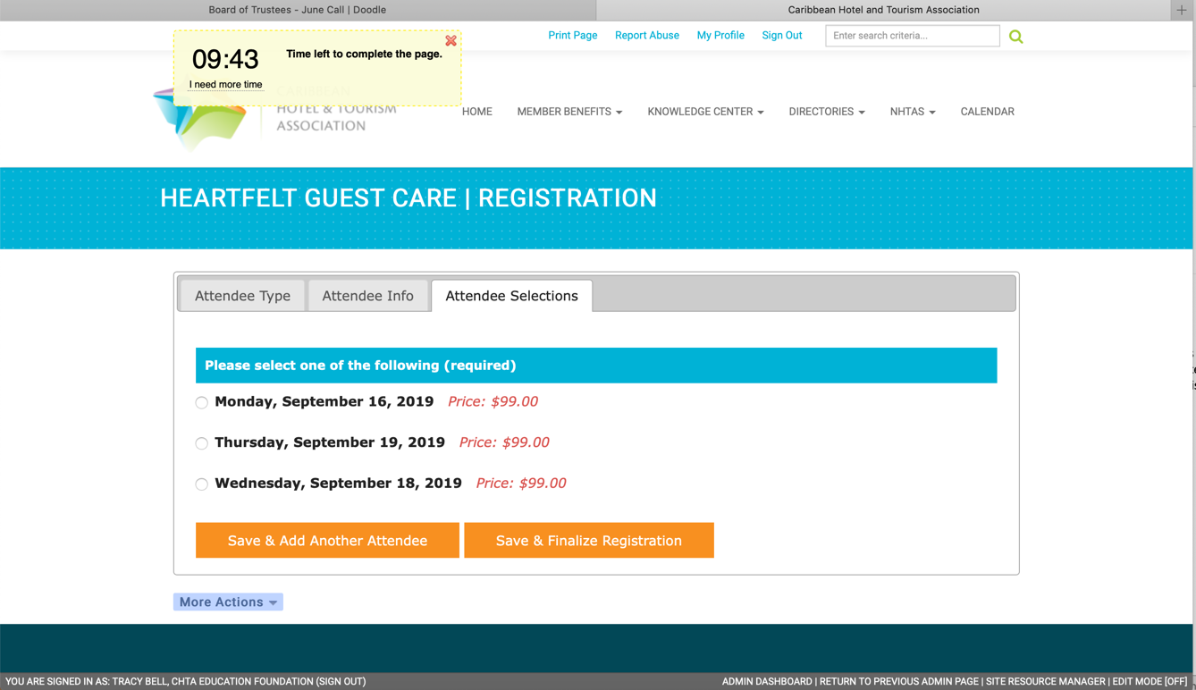

Step Four: Payment (Please note the timer on the top left of the page and add more time if needed to prevent losing previously entered data.
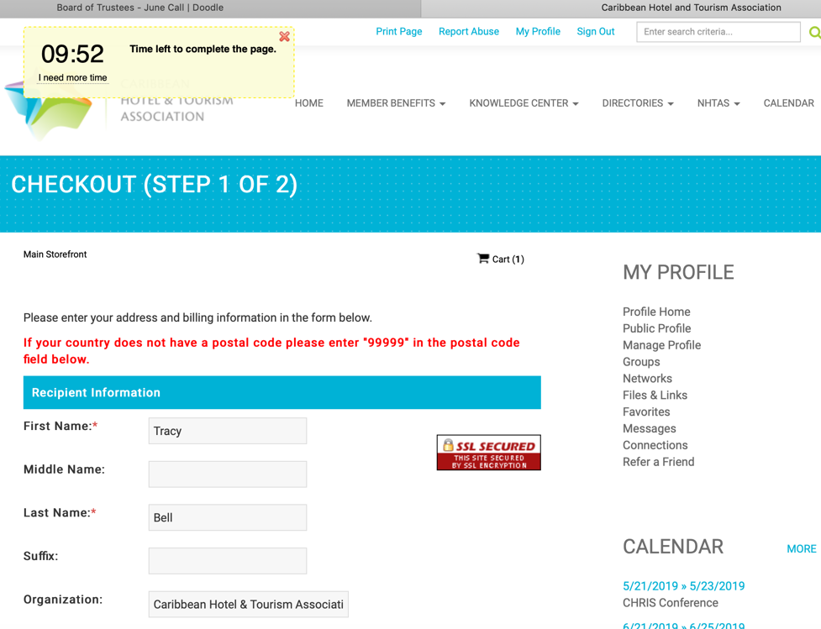 | The system defaults to US/Euro billing requirements which requires a postal code.  Addresses which do not have a postal code should enter “99999” in this required field.  The system defaults to the undiscounted price  Enter the promo code you have been assigned and click Apply  The discount will be applied to all participants registered.  Payment will be processed by Caribbean Hotel and Tourism Association

If you have any questions, please email Tracy Bell at foundation@caribbeanhotelandtourism.com

