Press release version



ForwardKeys Partners With Caribbean Hotel & Tourism Association to Deliver Regional Travel Insights

ForwardKeys, a leading travel intelligence partner, and the Caribbean Hotel & Tourism Association (CHTA) have joined forces to author an in-depth report on the state of Caribbean tourism. The report, set to be unveiled on May 20th at the upcoming Caribbean Marketplace event in Montego Bay, Jamaica, offers a comprehensive analysis of the region's performance and highlights critical trends shaping the industry's future.

The report reveals remarkable growth in the Caribbean, with international arrivals surpassing 2019 levels by an impressive 13% in the first half of 2024. However, as more destinations worldwide reopen, particularly in Asia, the region faces increasing competition for market share.

Key findings include the identification of top-performing destinations for the first half of 2024. Puerto Rico leads the way, followed by the Dominican Republic and Cancun in the Mexican Caribbean. Mid-tier destinations such as Belize and Curaçao also exhibit impressive growth, driven by increased connectivity and demand from key source markets.

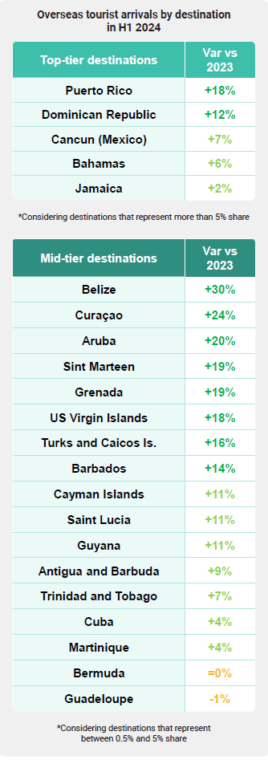 [to be replaced by a high-res version of the chart]

In addition to overall performance, the report delves into specific market segments, including business travel, family vacations, and high-yield visitors. Though business travel lags behind leisure, destinations such as the U.S. Virgin Islands, the Cayman Islands and the Dominican Republic show substantial growth in this segment. Family travel is also rising significantly, with Curaçao, Belize, and Aruba leading the way. Premium class travel, catering to luxury travellers, outperforms standard class bookings, presenting a valuable opportunity for Caribbean destinations to target this lucrative market.

Olivier Ponti, VP of Insights at ForwardKeys, commented, "As the Caribbean seeks to build on its success in the global tourism recovery, a data-based approach to destination promotion and management will be foundational for a sustainable, resilient, and profitable future for the region's tourism sector."

Nicola Madden-Greig OD, President of The Caribbean Hotel & Tourism Association, added, "To succeed in this new world, Caribbean hospitality and tourism businesses must harness data and technology to understand and anticipate shifting traveller needs. Working in partnership with travel intelligence leaders such as ForwardKeys equips our industry with the insights required to identify and target high-potential customer segments, optimise marketing strategies, and drive sustainable growth."

The CHTA-ForwardKeys report underscores the importance of data-driven insights in navigating the complex post-pandemic travel landscape. By leveraging ForwardKeys’ advanced analytics and actionable insights, Caribbean destinations can effectively adapt their strategies, capitalise on emerging opportunities, and maintain their competitive edge in the global tourism market.

About the Caribbean Hotel and Tourism Association (CHTA)
The Caribbean Hotel and Tourism Association (CHTA) is the Caribbean’s leading association representing the interests of national hotel and tourism associations. For more than 60 years, CHTA has been the backbone of the Caribbean hospitality industry. Working with some 1,000 hotel and allied members, and 32 National Hotel Associations, CHTA is shaping the Caribbean’s future and helping members to grow their businesses. Whether helping to navigate critical issues in sales and marketing, sustainability, legislative issues, emerging technologies, climate change, data and intelligence or, looking for avenues and ideas to better market and manage businesses, CHTA is helping members on issues which matter most.

For further information, visit www.caribbeanhotelandtourism.com.

