DRAFT

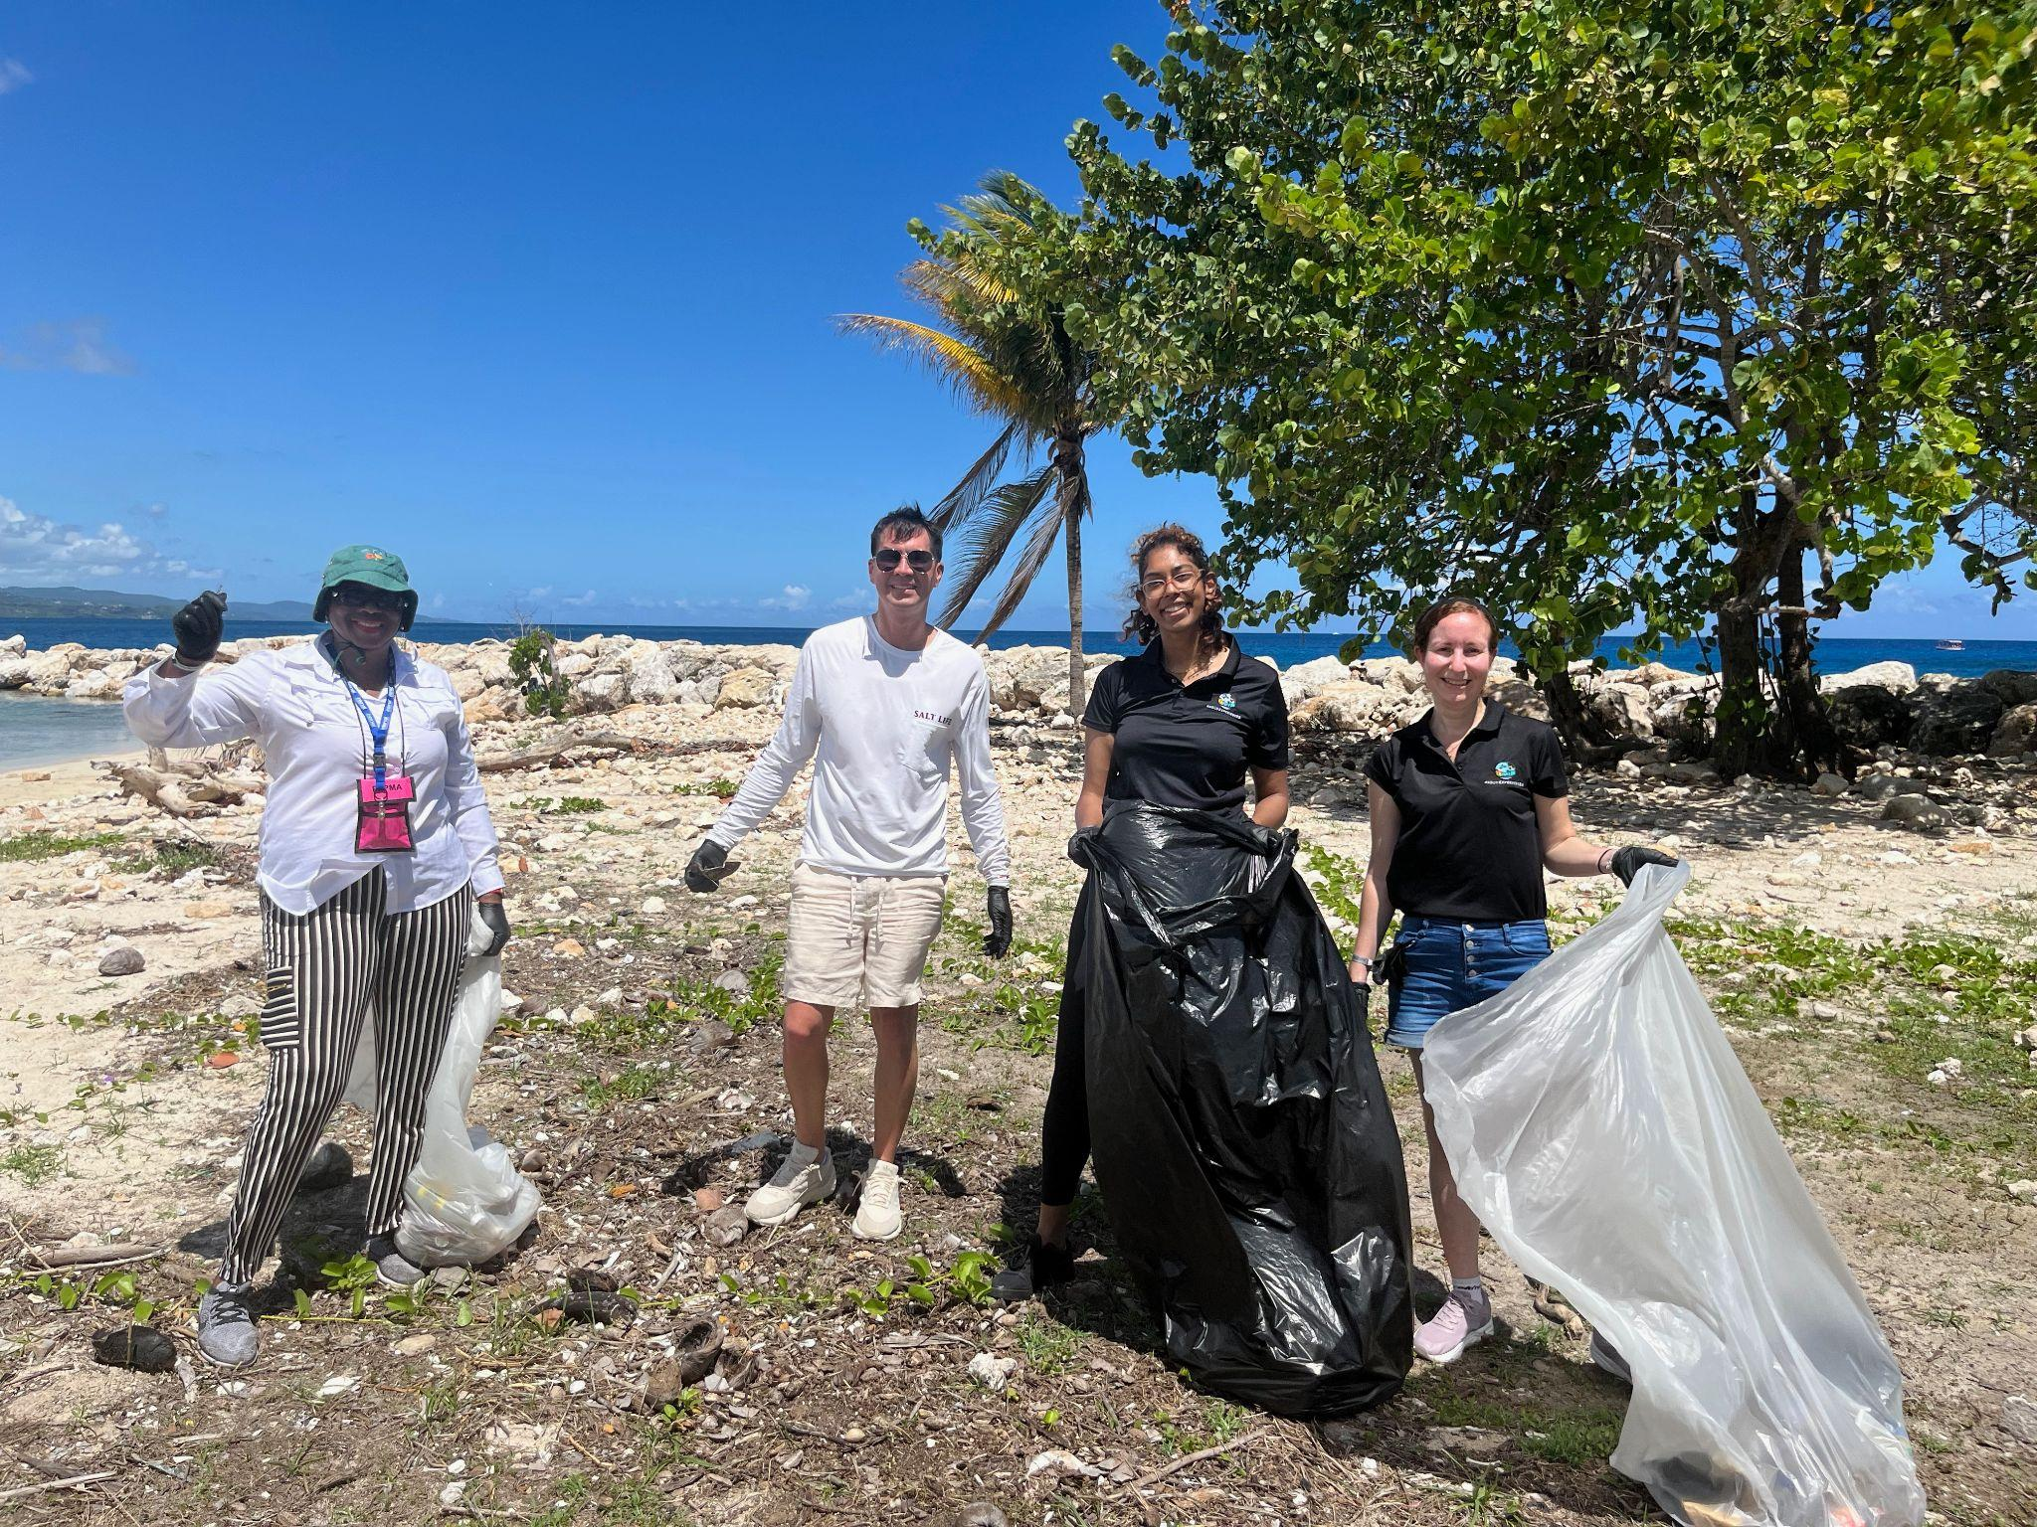

From left to right: Donna Monroe from Grand Bahama Island Promotion Board, Ruben Rosado from Holiday Inn Puerto Rico, and Rachael Nathaniel and Zara Lynch-Lewis from Hadco Experiences during the beach clean-up in Montego Bay, Jamaica, last week.

**CHTA Celebrates the Success of the Inaugural Marketplace Responsible Tourism Day**

MONTEGO BAY, Jamaica (May XX, 2024) – The Caribbean Hotel and Tourism Association (CHTA) celebrated a significant milestone with the launch of the first-ever Marketplace Responsible Tourism Day during this year’s Caribbean Travel Marketplace in Montego Bay, Jamaica. Held on Thursday, May 23, 2024, the groundbreaking event showcased sustainable tourism development, focusing on giving back to local communities in the host country of Jamaica.

“Marketplace Responsible Tourism Day has ignited a spirit of collaboration and innovation among tourism industry stakeholders. The enthusiasm and dedication shown by delegates in working together on sustainable initiatives are setting the stage for more integrated and cooperative approaches to tourism development,” said Nicola Madden-Greig, President of CHTA.

Participants rolled up their sleeves at the picturesque Croydon in the Mountains, planting 33 jackfruit and breadfruit trees while delving into sustainable agriculture practices. Delegates learned about the 1:1:1 Reforestation Initiative, which aims to provide each of the 1.2 million children in Jamaica's school system with a tree annually, promoting food sustainability and carbon sequestration.

A visit to the SOS Children’s Village in Barrett Town was another heartwarming highlight. Participants painted, conducted carpentry repairs and launched a village farming project. Over 40 delegates participated, with many generously donating clothing and school supplies, leaving a lasting impact on the children’s lives.

Delegates also participated in a beach clean-up at the Montego Bay Marine Park. This initiative spotlighted the importance of conserving and restoring coastal resources, providing an inspiring hands-on experience for everyone involved. About 100 pounds of trash was collected, significantly contributing to the conservation efforts at the Marine Park.

Rachael Nathaniel of Hadco Experiences commented on her team’s participation in the beach clean-up, “I was excited to be part of this initiative. We represent two ecological facilities in Trinidad, so caring for nature is very dear to our hearts, and we’re happy to give back to Jamaica.”

Marketplace Responsible Tourism Day contributes positively to the host community and is a valuable platform for learning, collaboration and commitment to sustainable tourism practices. It aligns with global trends towards more responsible travel and showcases the Caribbean’s dedication to leading the way in sustainable tourism.

For more information about the CHTA and all its initiatives across the Caribbean, visit [caribbeanhotelandtourism.com](http://www.caribbeanhotelandtourism.com).

ENDS